
 |  |  | 
 |  |  | 

User Manual – Query Module

“Framework contract for the provision of forest data and services in support to the European Forest Data Centre”
Reference: 2007/ S 194-235358 of 09/10/2007

Contents

1 Introduction 3
2 Welcome page 4
3 The Query module 5
3.1 Select a JRC Request 6
3.2 Add some fields you want to display 6
3.3 Launching the query 7
3.4 Pagination 7
3.5 Sorting the result 8
3.6 Displaying the plots on the map 8
3.7 Changing the query 9
3.8 Adding some criteria 9

Introduction

This document describes the use of the query module of the E-forest web site.

A temporary demonstration user has been created in order to allow the JRC members to test the web site before acceptance and before the consortium members send some real data.

Some test data (extracted from the Biosoil Biodiversity database) have been inserted in the database with the importation module.

In order to connect on the web site, you must go to the following address: http://efdac.ifn.fr/eforest and click on the login link on the upper right corner of the page.

The demonstration user is the following:
Login : JRCTest
Password : sETk8hB

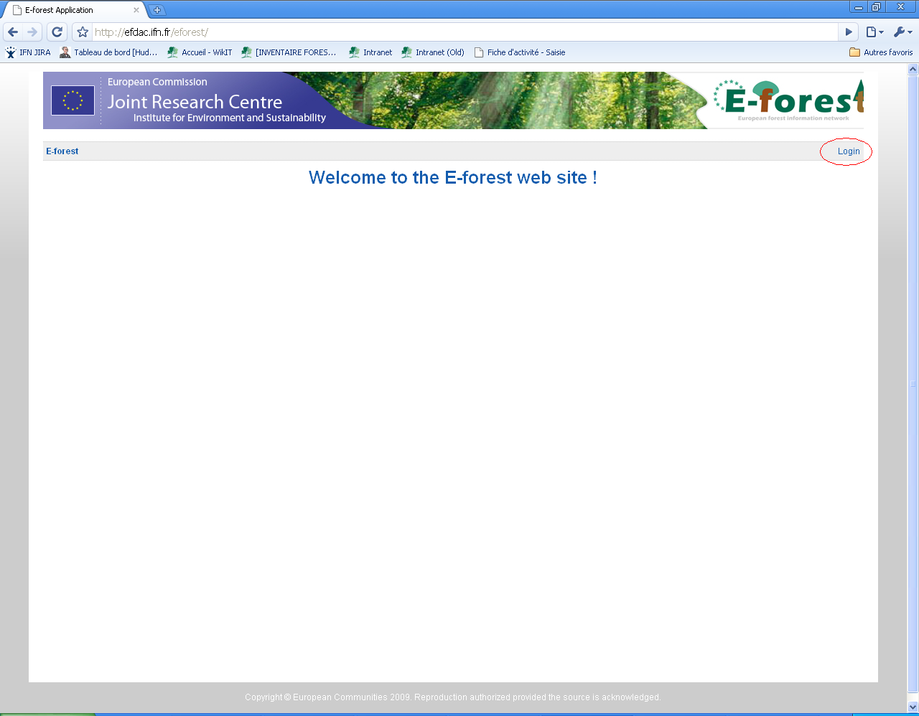

Welcome page

The welcome page of the web site allows you to access the different modules.

With the JRCTest user, the only available option is to go to the query module. Click on the link.

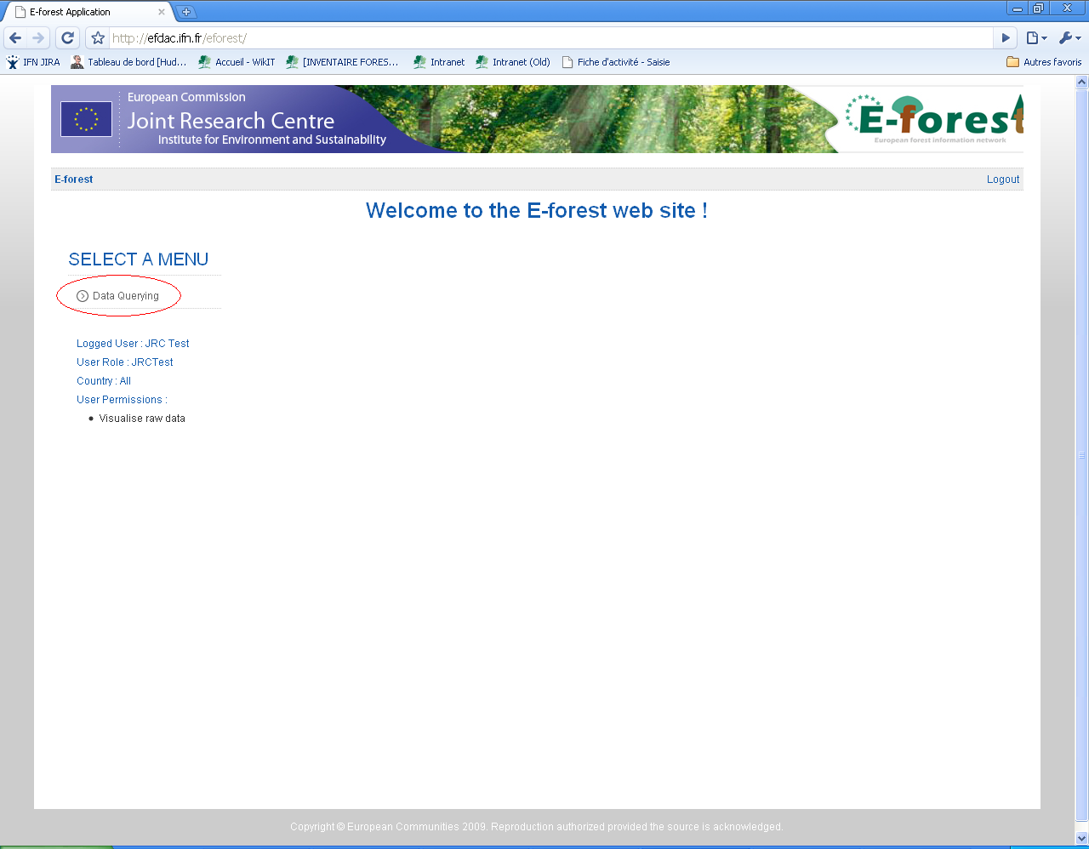

The Query module

The query module is decomposed liked this:

- On the left, we find the “Query Panel” which is used to compose the query.
  - Inside the query panel, we find a list of JRC Request.
  - For a given JRC Request, we find a list of Forms.
- On the centre of the page we find the result of our query. There is two tabs :
  - The Map view shows the map of Europe with the location of the plots
  - The Grid result view shows the values resulting from the request.

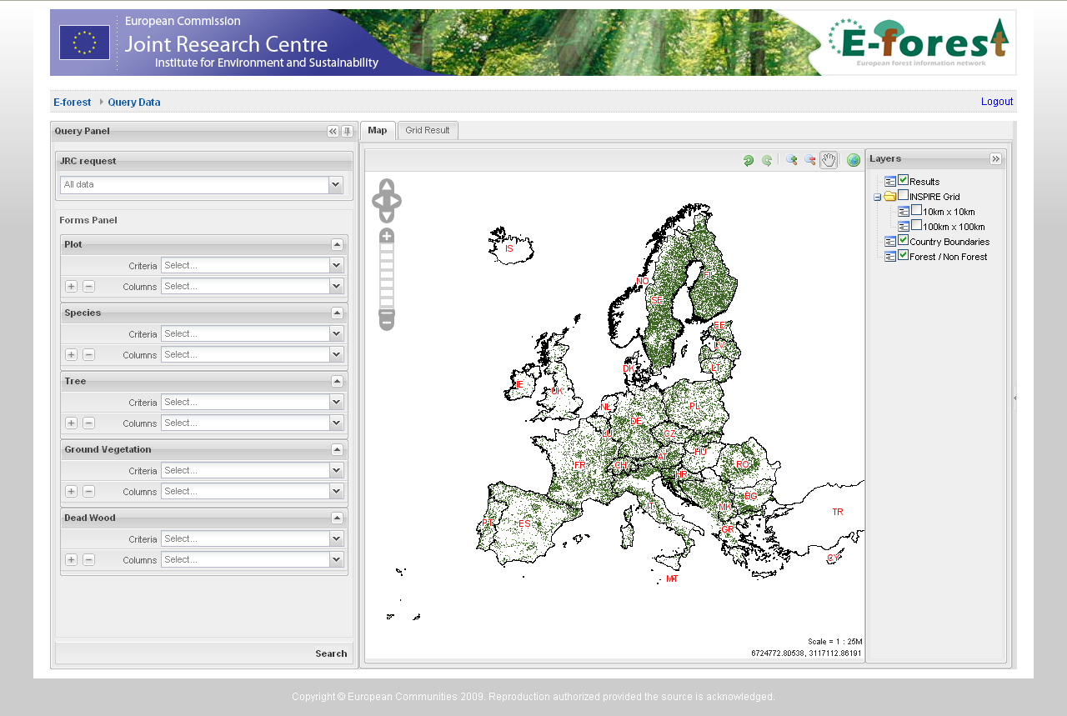

Select a JRC Request

The first thing to do when using the query module is to select the JRC Request we want to work with.

In the “JRC Request” combobox, select the “Biosoil Biodiversity Study”. You will see the list of available query forms change in order to include only the tables and fields corresponding to this JRC Request.

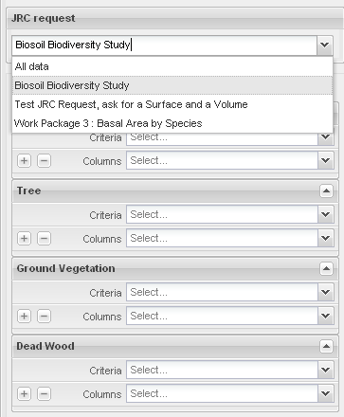

Add some fields you want to display

Each of the query forms in the forms panel allow you to select some criteria and some columns.

In order to make a query in the system, you must select some columns to display.
The “+” button can be used as a shortcut to add all the columns available for a given form.

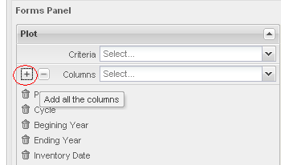

Launching the query

Click on the 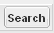 button at the bottom of the query panel in order to launch the request.

The result values should appear as a grid.

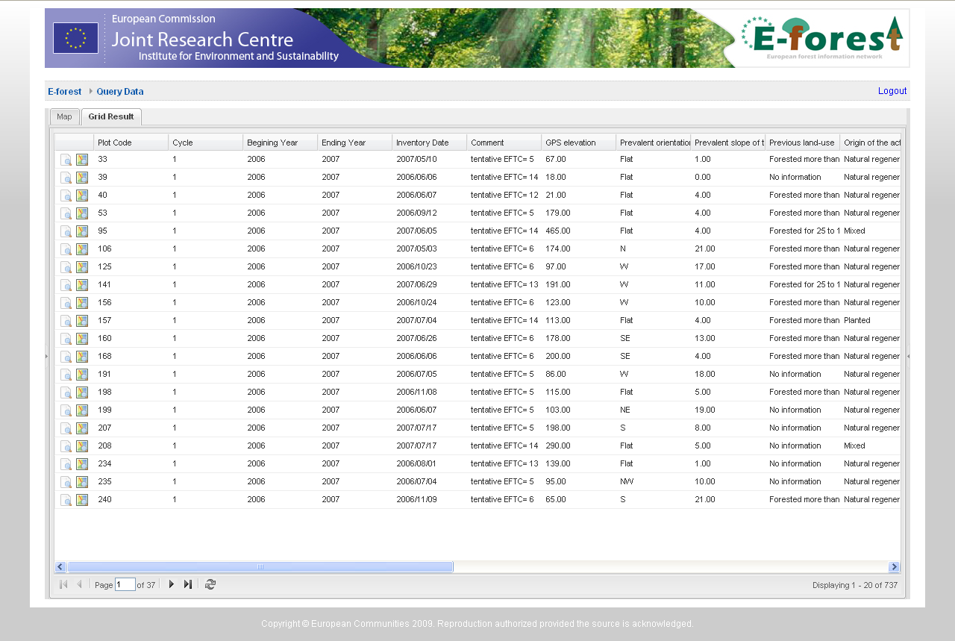

Pagination

The grid is limited to a maximum of 20 lines of result per page. You can navigate thru the results with the pagination tools at the bottom of the page.

Sorting the result

By clicking on the header of the columns, you can change the sorting options.

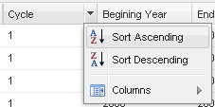

Displaying the plots on the map

By clicking on the “Map” tab, you can access to the cartographic view that will display the selected plot on the map of Europe.

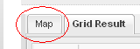

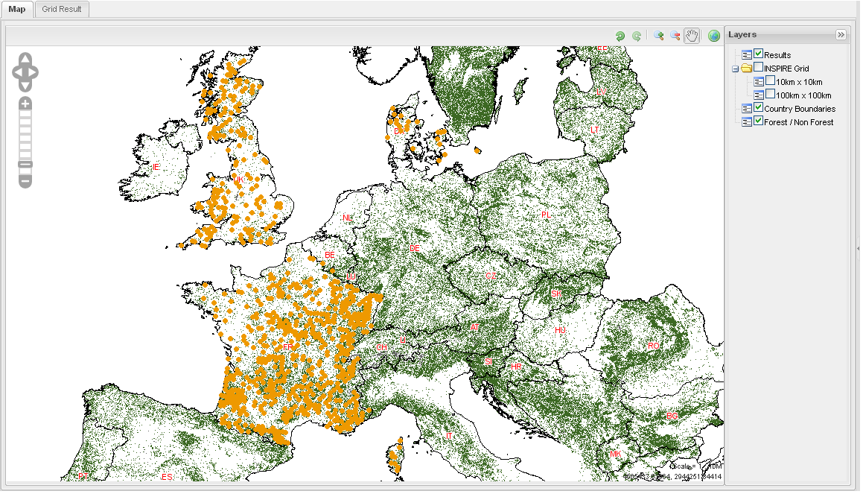

Some classical options are available on the map screen (moving the map, changing the zoom level, changing the layers, …).

Changing the query

If you want to change the query, you can show the query panel, that is just hidden under the result panel, by clicking on the arrow on the left side of the screen.
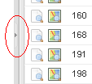

If you want to avoid the query panel from being hide, you can “pin” it using the icon on the upper right corner of the panel.

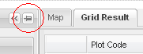

Adding some criteria

You can limit the results of your query by adding some criteria on each form.

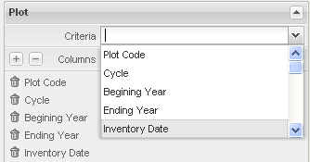

Depending on the type of the data you add as a criteria, the criteria form will be different.

For a text field, you will see a simple text box. The corresponding SQL Request will do a “LIKE %%”.

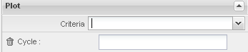

For a field of type “CODE”, you will see a combobox with the list of available codes.

You can add a criteria more than one time. In this case the generated SQL request will use a OR operator between each possible value.

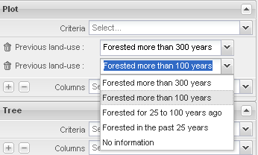

For a date field, you will see a “DateRangePicker” component that allow you to select a date or a range of dates.

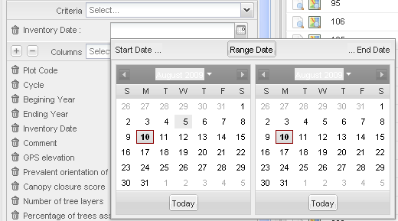

If you click on the “Start Date …” button, you will have to select the date corresponding to the begin of your search.
If you click on the “… End Date” button, you will have to select the date corresponding to the end of your search.
If you click on the “Range Date …” button, you will have to select both dates.

Example :

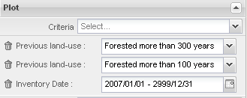

This combination of criteria will generate the following condition :
WHERE (LAND_USE = ‘1’ OR LAND_USE = ‘2’) AND (INV_DATE >= 2007/01/01)

